Practical Risk Management
A critical part of running any club is risk management—awareness of the club’s legal obligations and commitment to quality and safety and managing stakeholders, assets, activities, projects and services in a way that reduces exposure to risks.
This fact sheet introduces the fundamentals of practical risk management for STARCLUBs in the Northern Territory.
What is risk?
Risk is the chance of something happening that will have an impact on the club’s objectives. It is measured in terms of likelihood and impact.

What is risk management?
Risk management is the process of systematically eliminating or minimising the adverse impact of risks on the club’s objectives. Risk management should be a proactive rather than a reactive process.
STARCLUBs need to be aware of what risks can occur and take steps to lessen the chance of them happening. However, for some inevitable risks (such as injuries), clubs need to accept that they will occur and be prepared to deal with them.
The four types of risk
Physical | Risks involving personal injuries, environmental and weather conditions and the club’s physical assets, like property, buildings, equipment, vehicles, stock and grounds.
Financial | Costs associated with injuries, loss of financial stability and asset value, replacement costs, earning capacity and increased external administrative costs.
Ethical | Loss of positive participant experience and confidence, adverse publicity and damage to image. Actual or potential harm to the reputation or beliefs of the club.
Legal | Losses and costs arising from legal actions for breach of a common law, or statutory duty of care or breach of contract.

Examples of the type of risks sporting clubs face:
- property loss through risks like fire or burglary
- loss of sponsorship opportunities and member confidence due to bad publicity
- loss of top athletes through injury, which can cause further financial loss due to lost prize money, sponsorship or public interest
- unsafe equipment and facilities
- no emergency medical plan
- inadequate or inappropriate insurance
- the club being unincorporated
- the club not requiring participants to sign a waiver or release form prior to participating.

The five-step risk management process:
- Establish the context: before a risk can be understood and dealt with, it’s important to understand the environment it exists in.
- Identify the risks: identify what risks exist or may exist in the future by consulting with administrators, coaches, members, players and other key participants.
- Analyse and evaluate the risks: identified risks must be analysed, evaluated and rated to describe the likelihood of the risk occurring, the consequences of its impact on the club’s objectives and the priority or degree of urgency needed to address the risk. A simple risk matrix like this is a helpful tool:

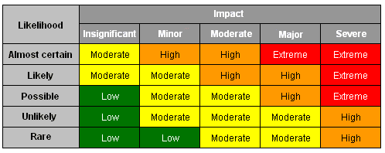

- Treat the risks: identify the most appropriate risk treatment option and implement it. Treatment options are accept the risk, avoid the risk, reduce the risk, transfer the risk, retain the risk or finance the risk.
- Monitor and review: an ongoing and integral part of risk management that ensures the important information generated by the risk management process is captured and used.

A simple risk management plan:
If you’ve never sat down to plan for risk in your club, a good place to start is by brainstorming and charting potential risks in a simple table like this:
What are the potential risks? | How will you reduce it? | Who will do it? | When will they do it by?

The benefits of a risk management plan:
- improved safety for participants, officials, spectators and volunteers
- lower costs and more budget certainty
- more effective management of assets, events, programs and activities
- improved compliance with the law, regulations and other formal requirements
- enhanced image and reputation
- increased interest in your sport and your club
- greater participation
- more financial support.

Other resources
Find more information Risk Management and Growing Your Sport click here.

