Increased powers for Aboriginal rangers to manage traditional lands
Discussion Paper
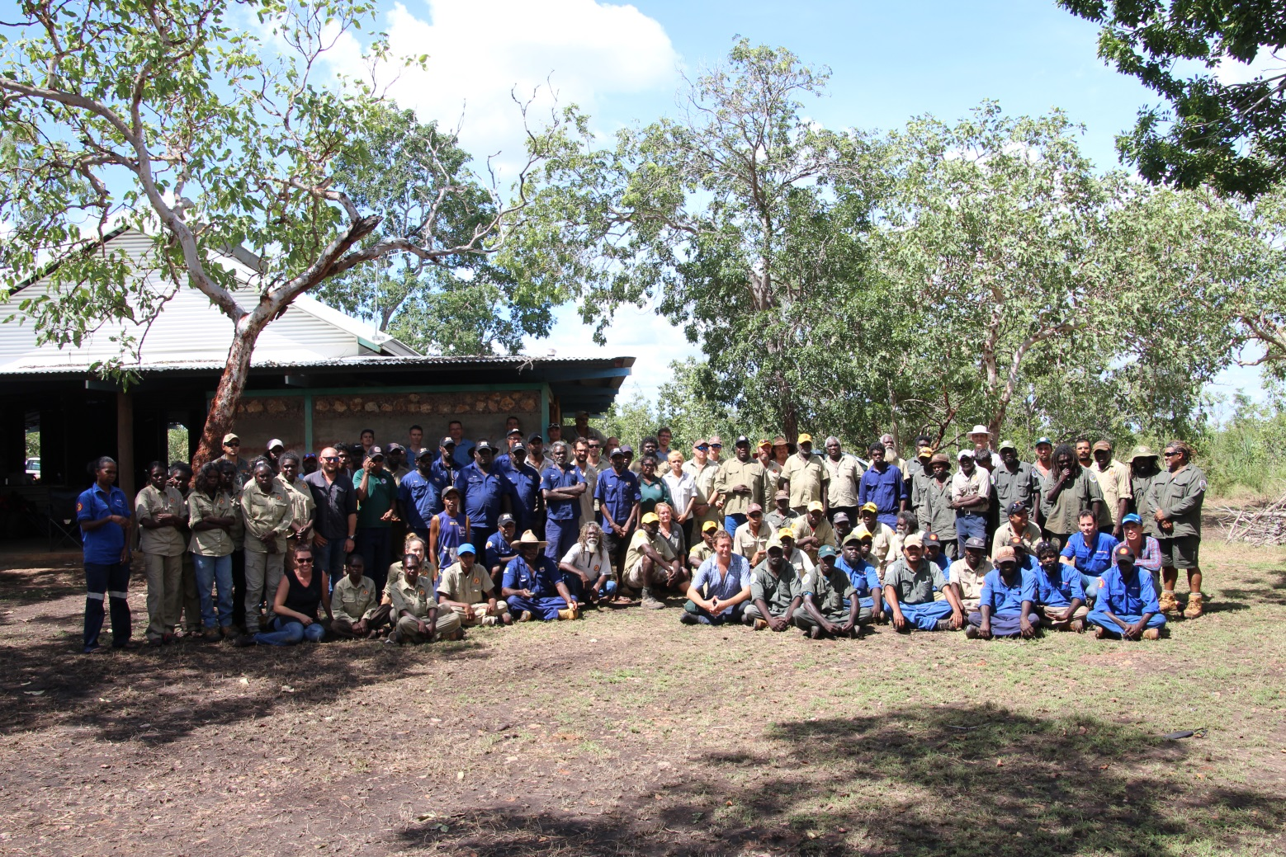

Contents
1 Background and context 3
2 Powers of Aboriginal rangers 3
2.1 Purpose 3
2.2 Input 3
2.3 Considerations 4
3 Process from here 5
4 Feedback 5

Cover Photo: Aboriginal Ranger Groups at the annual Arnhem Land Fire Abatement Fire Planning Meeting – April 2017 – Barrapunta Outstation, Arnhem Land.

Background and context
Aboriginal people have long held cultural and traditional responsibilities to protect and manage their land and sea country. Aboriginal owned and/or managed land occupies an estimated 50 per cent of the land area of the Northern Territory and approximately 85 per cent of the coastline is Aboriginal land. These lands are some of our most environmentally precious natural assets and, for Aboriginal people, are rich in cultural and spiritual meaning.
Aboriginal Ranger programs emerged during the mid-1990’s as Indigenous land owners increased their capacity to manage and protect country, and develop aligned environmental enterprises. The programs are widely recognised for their capacity to deliver long-term environmental, economic and social development outcomes, and are internationally recognised as best practice natural and cultural resource management models that successfully combine traditional ecological knowledge with Western science to manage and protect some of Australia’s most unique environments.
There are 46 established Ranger programs throughout the Territory, with approximately 1000 Rangers (full time, part time and casual). Aboriginal ranger group capability in compliance management is already recognised at a national level, with Aboriginal rangers now playing important roles in fisheries management, border security and quarantine protection. The Northern Territory Government, through the Fisheries Division of the Department of Primary Industry and Resources, works with several coastal Aboriginal ranger groups across the NT under its Indigenous Community Marine Ranger Program. The program recognises and supports Traditional Owners to be actively involved in the protection and management of their sea country. To date, these capabilities and the very significant role that Aboriginal ranger groups’ play in land management in the Northern Territory have not included land based enforcement powers.
Within this context, the Northern Territory Government is implementing a new policy initiative “Protecting Country, Creating Jobs”, which seeks to support Aboriginal rangers to protect the environment and create jobs. A key election commitment under this policy is an initiative to amend the Territory Parks and Wildlife Conservation Act (TPWCA), if necessary, to specifically recognise the role of Aboriginal ranger groups in managing natural and cultural assets across large parts of the Northern Territory and enable enforcement powers to increase the ability of groups to effectively manage traditional lands.
To achieve this, the Northern Territory Government, through its Department of Tourism and Culture is seeking feedback from Land Councils, Aboriginal organisations and other Aboriginal land management stakeholders on enforcement issues and priorities. This consultation process is an important step to ensure the proposed amendments meet Aboriginal ranger group members’ and Land Councils’ expectations to deliver the outcomes sought.
This Discussion Paper aims to start the conversation with Aboriginal ranger groups about enforcement priorities and how they see themselves participating in enforcement processes. This information will be used to develop and implement specific models and enforcement outcomes to meet this very important policy initiative.

Powers of Aboriginal rangers

Purpose
This Discussion Paper provides Aboriginal ranger groups and organisations with information about the input that the Department is seeking to identify management issues, methods of addressing those issues and the statutory powers wanted to achieve compliance outcomes.

Input
The Department requests that Aboriginal ranger groups and organisations consider the following questions to shape their input into increasing powers for Aboriginal rangers on traditional lands.
- What are the key compliance issues for your country?
- Do you already undertake compliance activities? If so, what powers do you currently use and under what legislative instrument are they enforced e.g. the Aboriginal Land Rights Act?
- What powers do you require to improve compliance on your country?
- Do you undertake compliance and enforcement training now? Is this training accredited or non-accredited training and is there a need to develop specific training courses for Aboriginal rangers?
- What other partners or stakeholders do you think should be included in the consultation process?

Considerations
A number of considerations have been identified in relation to increasing powers for Aboriginal rangers:
- The function of the Commission (Parks and Wildlife Division), established under the Parks and Wildlife Commission Act is to promote the conservation and protection of the Territory by participating in the management of parks, reserves, and sanctuaries established under the TPWCA or any other Act of the Territory or Commonwealth and other land by agreement with the owners or occupiers of that land; and to encourage the protection, conservation and sustainable use of wildlife.
- The Minister may currently appoint Aboriginal rangers as Honorary Conservation Officers under the TPWCA.
- The TPWCA also has other existing provisions that could apply to Aboriginal land if an agreement is entered into. Any amendments will need to be consistent with the Aboriginal Land Rights (Northern Territory) Act.
- The Executive Director of the Parks and Wildlife Division must determine the level of training required for Honorary Conservation Officers. At present, Honorary Conservation Officers with partial powers must have completed a minimum of six months on the job experience and one of the following courses:
  - Certificate IV in Government (Statutory Compliance)
  - Certificate IV in Government (Investigation)
  - The Department’s course entitled “Conservation Officer Training”
  - Study considered by the Director of Wildlife Operations to be equivalent to those above.
- A Conservation Officer or Honorary Conservation Officer is an important role that carries a high degree of responsibility.
- Not all Parks and Wildlife Rangers are Conservation Officers with full or partial compliance powers. Out of approximately 150 rangers, 35 are Conservation Officers with full powers and a further 37 have partial powers.
- Prosecutions are rare. Two prosecutions occurred in the past 12 months – one for the taking of wildlife for commercial purposes and one for the possession of firearms on Park, which NT Police ran in conjunction with other offences.
- 29 Infringement Notices were issued across the Territory in the past 12 months, 28 of which were issued for breaches against the By-Laws.

Process from here
A number of key milestones have been drafted to meet this election commitment. The feedback from this discussion paper will lead to the identification of possible enforcement models. Formal consultation with the stakeholders regarding specific models and enforcement outcomes will be required.
- November 2017 – Distribute discussion paper to Land Councils, Aboriginal rangers and Aboriginal stakeholders for comment.
- November 2017 - February 2018 – Comments period for discussion paper.
- March 2018 - Summary of representations and options briefing prepared for Ministerial consideration.
- April 2018 – Decisions and next steps communicated to key stakeholders and the wider community.

Feedback
Feedback from Aboriginal ranger groups and organisations on the questions posed above, and any other input in relation to the proposed increase in powers for Aboriginal rangers, can be provided in a number of ways. An electronic version of the Discussion Paper can be accessed at: nt.gov.au/traditional-land-management.
Parks and Wildlife Division staff are available to meet with any ranger groups or organisations who wish to discuss the matter in person. Contacts are provided on the following page.
Please direct written and verbal responses to Neva McCartney, Director Northern Australian Parks. Submissions close on 28 February 2018.
Neva McCartney
Director of Northern Australian Parks
Parks and Wildlife Division
Department of Tourism and Culture
PO Box 1448
DARWIN NT 0801
Phone: 08 8999 4561
Mobile: 0428 102 574
Email: neva.mccartney@nt.gov.au

The following staff are also available to meet with interested parties in the Katherine and Alice Springs regions.
Chris Day
Director of Central Australian Parks (Alice Springs / Barkly)
Phone: 8951 8251
Mobile: 0427 601 237
Email: chris.day@nt.gov.au

Sarah Kerin
Director Savannah / Gulf Parks (Katherine / VRD / Gulf)
Phone: 8973 8819
Mobile: 0476 815 489
Email: sarah.kerin@nt.gov.au

