NTIS Officiating Development Grants 2020-2021
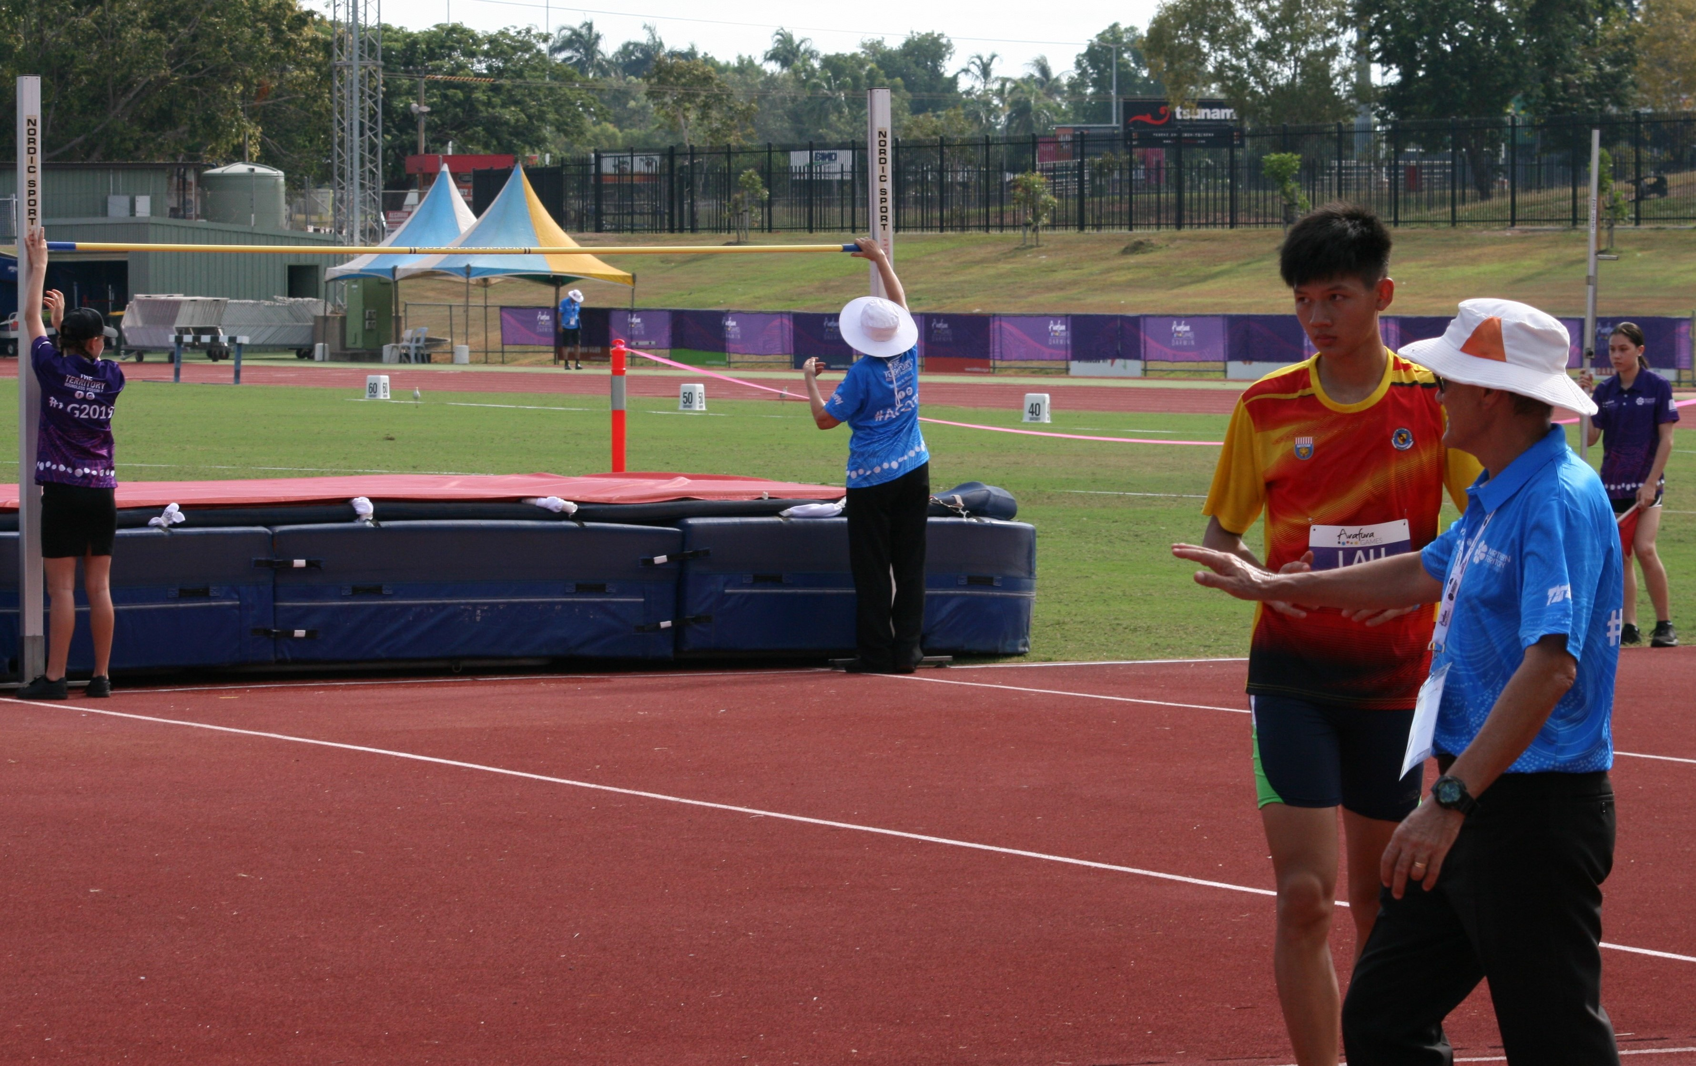

Document title | NTIS Officiating Development Grants 2020-2021
Contact details | (08) 8922 6841 or NTIS.CoachAndOfficial@nt.gov.au
Approved by | Ian Ford/Brenton Toy
Date approved | 12 August 2020
Document review | Annually
TRM number | SR2020/0067-0001~0002

Version | Date | Author | Changes made
1.0 | 20/07/20 | Graham Glassford | Inclusion of academies grant category
2.0 | 07/08/20 | Graham Glassford | Wording change in 6.1 and 6.2, deletion of application checklist, addition of budget information required

Acronyms | Full form
NSO | National Sporting Organisation recognised by Sport Australia.
NT | Northern Territory
NTG | Northern Territory Government
NTIS | Northern Territory Institute of Sport
OD | Officiating Development grant
PSB | Peak Sporting Body recognised by the NTG

Contents
1. Overview 4
2. Key dates 4
3. How to apply 4
4. Who can apply? 5
4.1. NT Peak Sporting Bodies 5
5. Who cannot apply? 5
6. What can be funded? 6
6.1. Officiating Coaches/Educators 6
6.1.1. Funded categories: 6
6.1.2. Funding will not be considered for: 6
6.2. Accreditation Courses and Competitions 7
6.2.1. Funded categories: 7
6.2.1.1. Accreditation Courses 7
6.2.1.2. Competitions 7
6.2.2. Funding will not be considered for: 7
6.3. Officiating Academies (Round 2 only) 8
6.3.1. Eligibility for Officiating Academy applications: 8
6.3.2. Minimum program requirements: 8
6.3.3. What can be funded 8
6.3.4. Funding will not be considered for: 8
7. Budget information required 9
8. Assessment 9
9. Notification and Feedback 9
10. Payment of funding 10
10.1. Goods and Services Tax (GST) 10
11. Buy Local 10
12. General information 10
13. Definitions 11
14. Contact information 11

Overview
The Northern Territory Institute of Sport (NTIS) Officiating Development grant is a Northern Territory Government (NTG) initiative administered by the Department of Tourism, Sport and Culture (the Department).
There are three funding categories, Development of Officiating Coaches/Educators, Accreditation Courses and Competitions and Officiating Academies. Two rounds of applications will be conducted in 2020-2021 however applications for the Officiating Academies category will only be open in the Round 2 grant cycle.
In Round 1 Peak Sporting Body’s (PSB’s) can apply for a grant in either or both funding categories to a maximum of $4000 in each (i.e. maximum $8000).
In Round 2 Peak Sporting Body’s (PSB’s) can apply for a grant in either or all funding categories to a maximum of $4000 in each (i.e. maximum $12000).
The primary objectives of this grant program are:
- Strengthen the capability and capacity of sport organisations to assess, coach, mentor, and educate other NT officials;
- Increase the number of Territorians officiating at the highest levels in sport; and
- Improve the knowledge, skills and experience of accredited sport officials participating in the Northern Territory (NT).

Key dates
Round 1
Applications open online 14 September 2020
Closing date for applications 14 October 2020
Assessment of applications October 2020
Agreements finalised and funds available November 2020
Funding period 1 November 2020 onwards

Round 2
Applications open online 1 February 2021
Closing date for applications 28 February 2021
Assessment of applications March 2021
Agreements finalised and funds available April 2021
Funding period 1 April 2021 onwards

How to apply
Round 1 applications open on 1 September 2020
Round 2 applications open on 1 February 2021
All applications must be lodged online via Grants NT https://grantsnt.nt.gov.au/
It is highly recommended you contact the Department for assistance with your application prior to submitting. Phone (08) 8922 6811 or email NTIS.CoachAndOfficial@nt.gov.au

Who can apply?

NT Peak Sporting Bodies
The PSB must:
- Be currently registered as an incorporated body with the NT Department of Trade, Business, and Innovation or hold another comparable legal status;
- Operate as a not-for-profit organisation;
- Be compliant with Licencing NT, or other relevant authority; and
- Have current public liability insurance (minimum $10M).

Who cannot apply?
- Clubs, associations, regional councils, other organisations that do not meet the Department’s definition of a NT Peak Sporting Body;
- Individuals;
- Parents and citizens/parents and friends associations;
- State and federal government departments;
- For-profit groups/commercial organisations;
- Tertiary education institutions, school councils, student groups;
- Organisations that are not based in the NT; or
- Organisations with outstanding government grant acquittals.

What can be funded?

Officiating Coaches/Educators
Funding is provided for officiating coaches/educators. Examples of the types of projects supported in each are listed below.
It is important that your application clearly provides the project details (the why), project activities (what and how the project is delivered) and the project measurables (specific outcomes on judging the success of the project) and that funding requested is directly aligned with these guidelines.
Previous successful applicants, while welcome to apply, cannot submit an application for a similar funding category (as per below) while having a current unacquitted grant (unless an extension of the grant was provided due to COVID-19).

Funded categories:
Costs associated with delivering:
- An officiating coaching accreditation/ training course including the travel of an intra-Territory or interstate presenter.

Costs associated in attending:
- An officiating coaching accreditation/ training course intra-Territory or interstate;
- A sport specific officiating presenters/ assessor/ deliverers/mentor course conducted by your sport.

Professional development costs associated with attending:
- An intra-Territory or national competition to provide officiating coaching under supervision of a mentor/coach.

Funding will not be considered for:
- Activities or projects that have been approved under other NTG grant programs;
- Activities or projects that are normally covered by the National Sporting Organisation (NSO);
- Applications that are not supported by a breakdown of costs;
- Overheads involved with running an officiating coaching course including room hire, facility usage and cost of support materials such as printing and binding of manuals;
- Hire car associated with attending an event;
- Meals associated with attending an event;
- Equipment or clothing (including uniform items);
- Fees to maintain accreditation.

Accreditation Courses and Competitions
Funding is provided in two sections, accreditation courses and/or competitions. Examples of the types of projects supported in each are listed below.
It is important that your application clearly provides the project details (the why), project activities (what and how the project is delivered) and the project measurables (specific outcomes on judging the success of the project) and that funding requested is directly aligned with these guidelines.
Previous successful applicants, while welcome to apply, cannot submit an application for a similar funding category (as per below) while having a current unacquitted grant (unless an extension of the grant was provided due to COVID-19).

Funded categories:

ACCREDITATION COURSES
Costs associated with delivering:
- An intermediate or higher officiating training course including the travel of an intra-Territory or interstate presenter.

Costs associated with attending:
- An intermediate or higher officiating training course intra-Territory, interstate or overseas.

COMPETITIONS
Costs associated with officials officiating:
- At an event as part of higher level accreditation requirements.
- At an international selection event (not fully funded by the PSB or NSO) that assists in being selected for a higher level competition;
- At a state, national (including School Sport Australia) or international event (not fully funded by the PSB or NSO) that assists in maintaining accreditation; or
- At a state, national or international competition on the officiating pathway.

Funding will not be considered for:
- Activities or projects that have been approved under other NTG grant programs;
- Activities or projects that are normally covered by the NSO;
- Applications that are not supported by a breakdown of costs;
- Applications from organisations in the officiating stream proposing to run beginner or introductory officiating courses in the NT*;
- Overheads involved with running an officiating course including room hire, facility usage and cost of support materials such as printing and binding of manuals;
- Hire car associated with attending an event;
- Meals associated with attending an event;
- Car parking
- Equipment or clothing (including uniform items);
- Costs associated with being an announcer or ball person at an event;
- Fees to maintain accreditation;
- Participation in competitions that are not part of the NSO’s or PSB’s recognised officiating pathway. The scholarship is to support officials to reach the highest levels in the sports official pathway.

* PSB’s receive annual grant funding to support
these courses.

Officiating Academies (Round 2 only)
Funding is provided to a PSB as seed funding (first year only) to establish an Officiating Academy. The academy can be either inclusive or exclusive. Sports with existing officiating academy structures are ineligible.
Funding applications will be open for the Round 2 grants process (February 2021).

Eligibility for Officiating Academy applications:
- An officiating coaching structure;
- An officiating operational plan that is also linked to the PSB Strategic Plan;
- An officiating pathway relatable to the NT (i.e. where the academy fits into the NT pathway);
- A detailed budget for the academy including any co-investment from the PSB or other organisations;
- A plan for the sustainability of the academy after the first year of seed funding; and
- A completed project proposal template (which will be provided).

Minimum program requirements:
- Be conducted over the duration of a season;
- Engage all regions where the sport is conducted;
- Engage officiating coaches/educators/mentors with the delivery of the academy; and
- All officials involved in the academy program must have the minimum level of accreditation and have been officiating for at least one season.

What can be funded
- Intra-Territory travel and accommodation of officials involved in the Academy;
- Coaching honorariums (up to no more than 50% of funding applied for);
- Academy uniforms (up to no more than 25% of funding applied for);
- Performance consultants (e.g. nutrition, sports psychology etc.) that reside in the NT; and
- Venue hire.

Funding will not be considered for:
- Any interstate travel;
- Offsetting wages of employed staff;
- Offsetting travel/accommodation costs of employed staff;
- Any application that does not meet the conditions as set out in 6.3.1 and 6.3.2;
- Any costs associated with delivery of officiating accreditation courses; and
- Equipment purchases;

Budget information required
The following is a checklist of budget information and documents that are required for your application.
- Detailed income and expenditure.
- All quotes and estimations used for the budget.
- Detail as to whether the budget is calculated excluding or including GST.

Assessment
Total funding is limited and subject to annual variation by the NTG. As such, all applications will be assessed on relative merit against selection criteria. It is not possible to approve all requests for assistance, therefore grant funding should not be deemed automatic or anticipated, regardless of history or previous funding.
The application’s activities requested for funding will be cross-checked with other Department grant funding applications for duplication.
High Priority for Funding
- Applications in the category of Officiating Coaches/Educators (this also includes instructors, assessors etc.) are deemed a high priority to fund given they support all of the primary objectives of the grant.
- Applications that include development of regional/remote officials with specific details of the project, outcomes and activities.
- Applications in the category of Officiating Academies (Round 2 only).

Notification and Feedback
Applicants will be notified of the result of their application by email. Successful applicants and funding details may be published on the Department’s website www.dtsc.nt.gov.au
PSB’s with a successful application will receive a grant agreement which will outline the level of funding approved and the approved initiative.
The PSB must agree to comply with the conditions outlined in the agreement, sign the agreement, and return it to the Department so the funds can be paid.
Unsuccessful Round 1 applications which meet the criteria may re-considered in Round 2. PSB’s will be contacted to advise whether they would still like to be considered for assessment.

Feedback is available on request.

Payment of funding
Payments will be processed upon the receipt of the signed agreement and will be paid via electronic funds transfer (EFT) to the organisation’s nominated bank account.

Goods and Services Tax (GST)
If the organisation is GST registered, the actual total is subject to GST and the following will apply:
- The total will be ‘grossed up’ by 10 per cent;
- It is the organisation’s responsibility to ensure that the GST component is remitted to the Australian Taxation Office;
- A ‘Recipient Created Tax Invoice’ will be generated showing the ‘grossed up’ amount and forwarded to the organisation once the funds have been released;
- If the organisation is not registered for GST, the organisation is not required to pay GST and will not receive a ‘grossing up’ provision; and
- The organisation must advise the Department of any changes to its ABN or GST registration status.

Buy Local
The NTG is committed to supporting local Territory businesses through its Buy Local Plan. Applicants must use labour, services, supplies and material available within the NT, except where it can be reasonably demonstrated that it is impractical for commercial, technical or other reasons.
www.buylocal.nt.gov.au

General information
- These guidelines supersede all terms and conditions in previous guidelines administered by the Department and form part of any agreement for funding provided under this program.
- Funds may not be used for any other purpose without a request for variation and prior written approval from the Department.
- Funds are not granted retrospectively i.e. to projects that have occurred or commenced prior to the application or notification of success.
- Recipients will be required to comply with all conditions of a NTG agreement which includes participation in audits of funding use.
- The NTG reserves the right to withdraw approval for funding at any time if there is a change in circumstances in the nature or financial viability of the project, individual or organisation.
- If a funding recipient does not meet all requirements in the agreement, monies paid may be recovered as a debt due.
- Unexpended funds of the approved amount will be required to be refunded.
- Recipients will be required to acknowledge the government assistance (information on how to do this will be detailed in the agreement).
- It is a condition of application that details of successful and unsuccessful applications, including the name of the organisation, amount, purpose, and any special approval conditions may be published or used by the NTG in any form and at any time.

Definitions
Accreditation
The NSO’s competency based training program is required to be completed by an official in order to be nationally recognised within the sport. There are flexible methods of delivery of the curriculum (e.g. in a face to face classroom setting, through mentor sessions, face to face practical learning, e-learning, or a mixture of methods). It has previously been called the National Officiating Accreditation Scheme (NOAS).
Introductory Accreditation
The NSO’s introductory level qualification in your sport’s officiating pathway, it may be known as Community, Beginner, or Level 1 accreditation.
Official
Is a person who controls the running of a competition by applying the rules and laws of the sport. “Official” is the generic word, other titles include; referee, scorer, linesperson, umpire, judge, technical official, chair umpire, timekeeper, commissaire, tournament director or marshal. Sport officials also include coaches/educators of officials. Each type of official should have an NSO recognised training program. Not included are persons in roles related to sport/team/event administration/management, announcers or coaches of athletes.
Officiating coaches/educators
Is a person that is responsible for training officials by analysing their performances, instructing in relevant skills, assessing competencies as per the NSO’s accreditation framework/guidelines and by providing encouragement. Coaches/educators can also be known in sport as assessors, developers, mentors, observers or instructors.

Contact information
Northern Territory Institute of Sport
Level 1, Arafura Stadium, 40 Abala Road
Marrara NT 0810
Telephone: 08 8922 6811
Email: NTIS.CoachAndOfficial@nt.gov.au

